Post-Development Testing

By Farhan Mirza

My Final Testing

Usability Testing

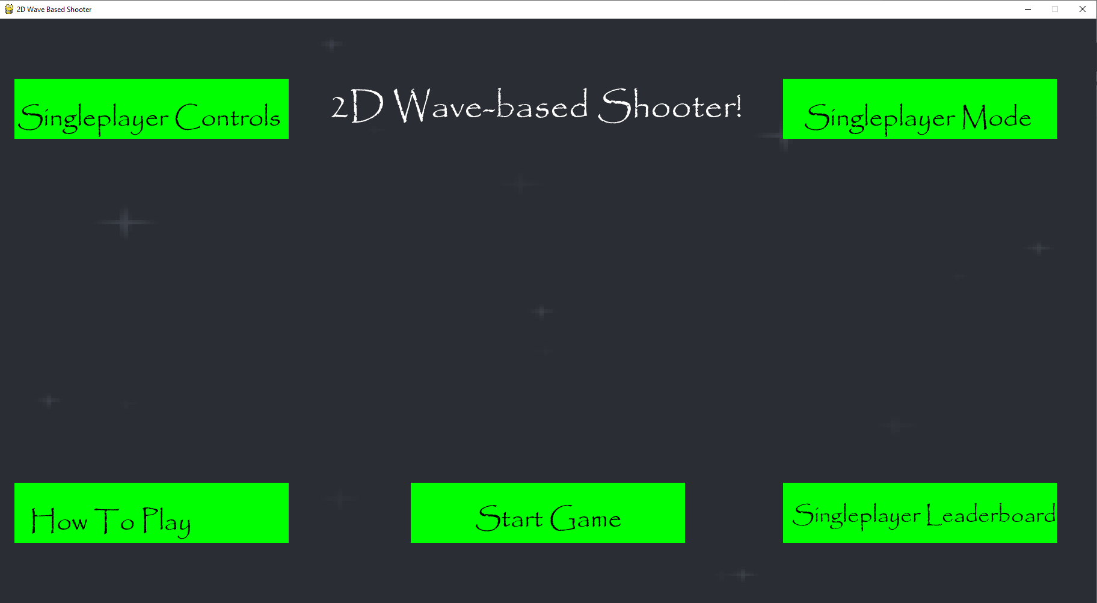In the starting screen of the main menu, all the text for all the boxes is clearly visible and clearly shows what each of the sections contain when you click on them.

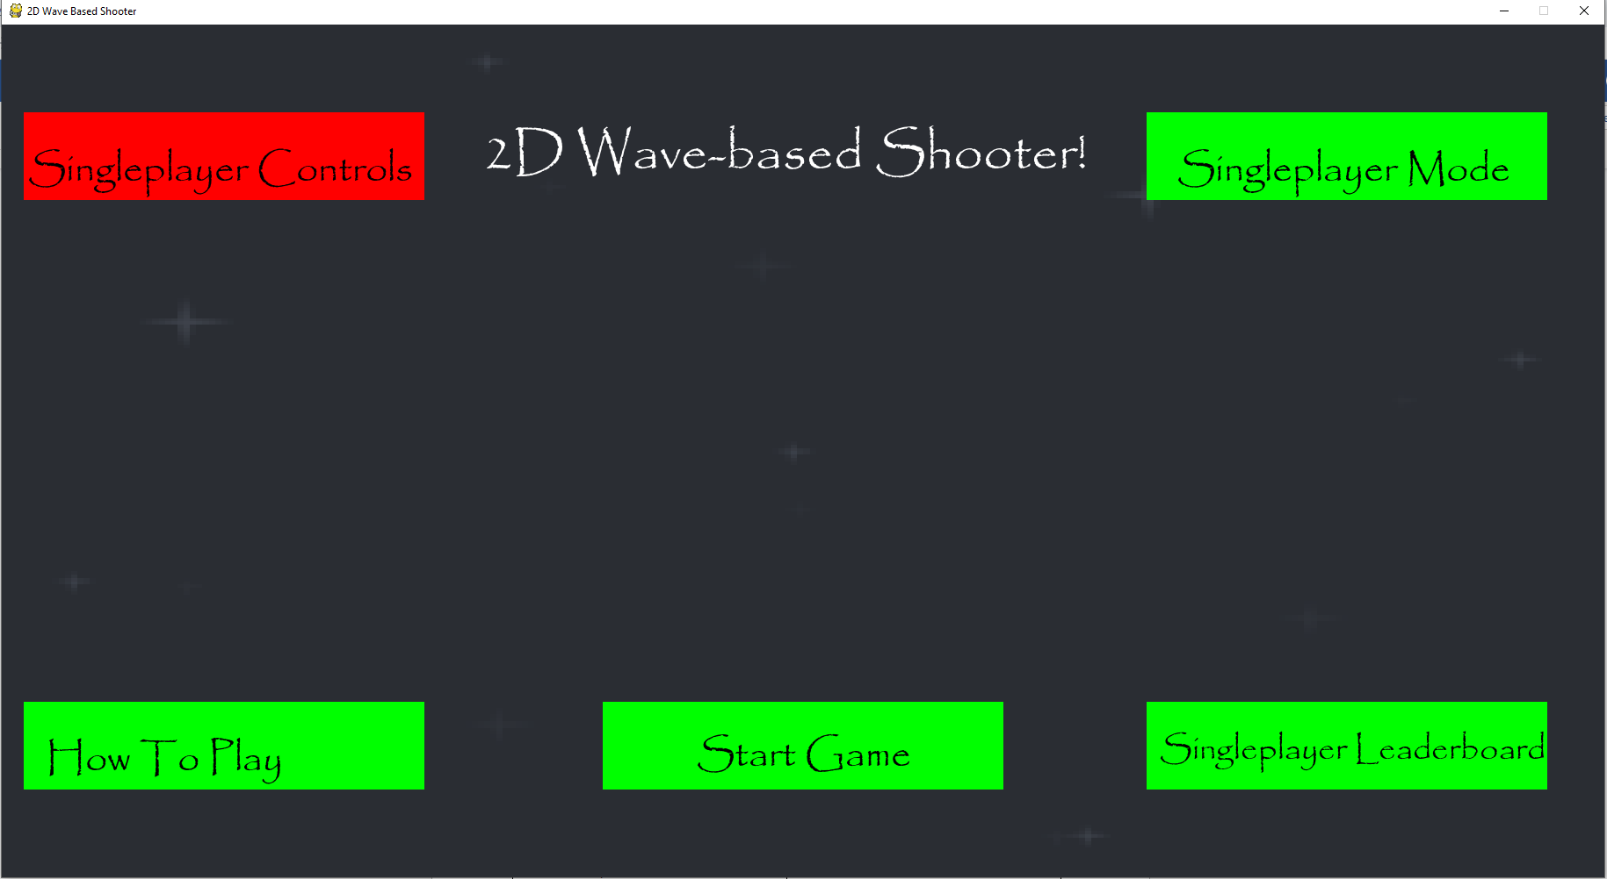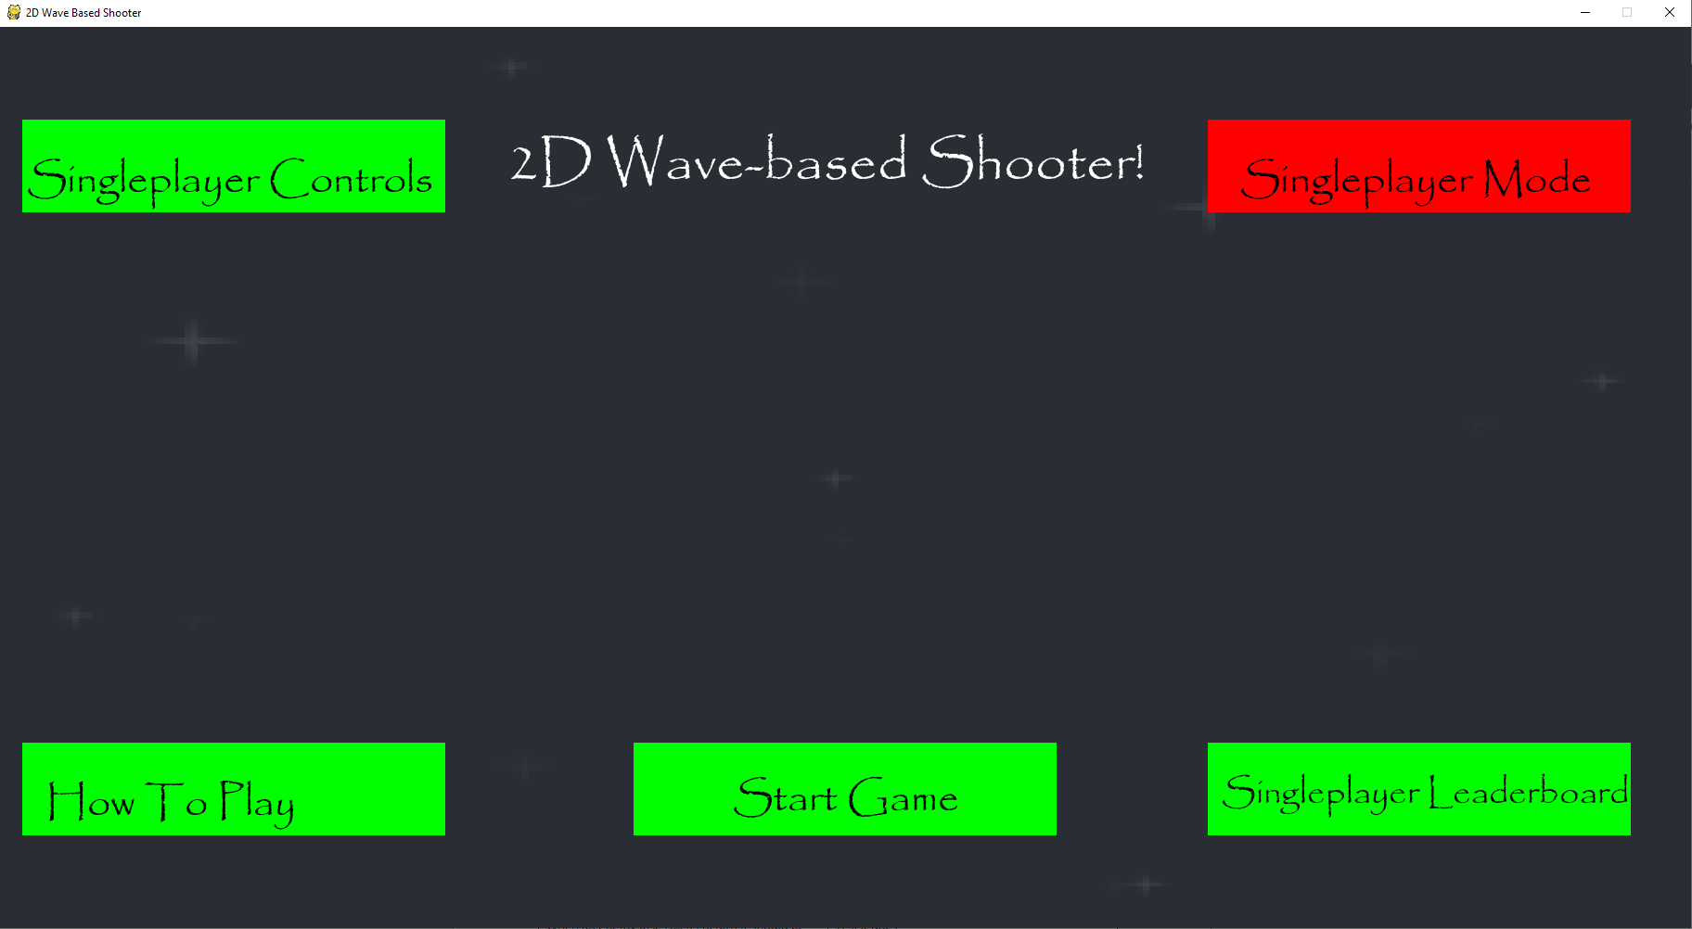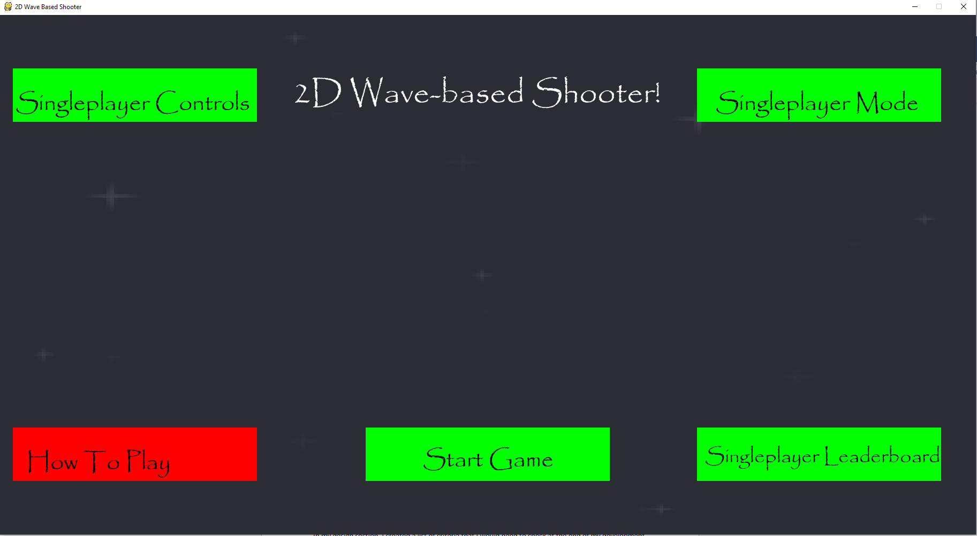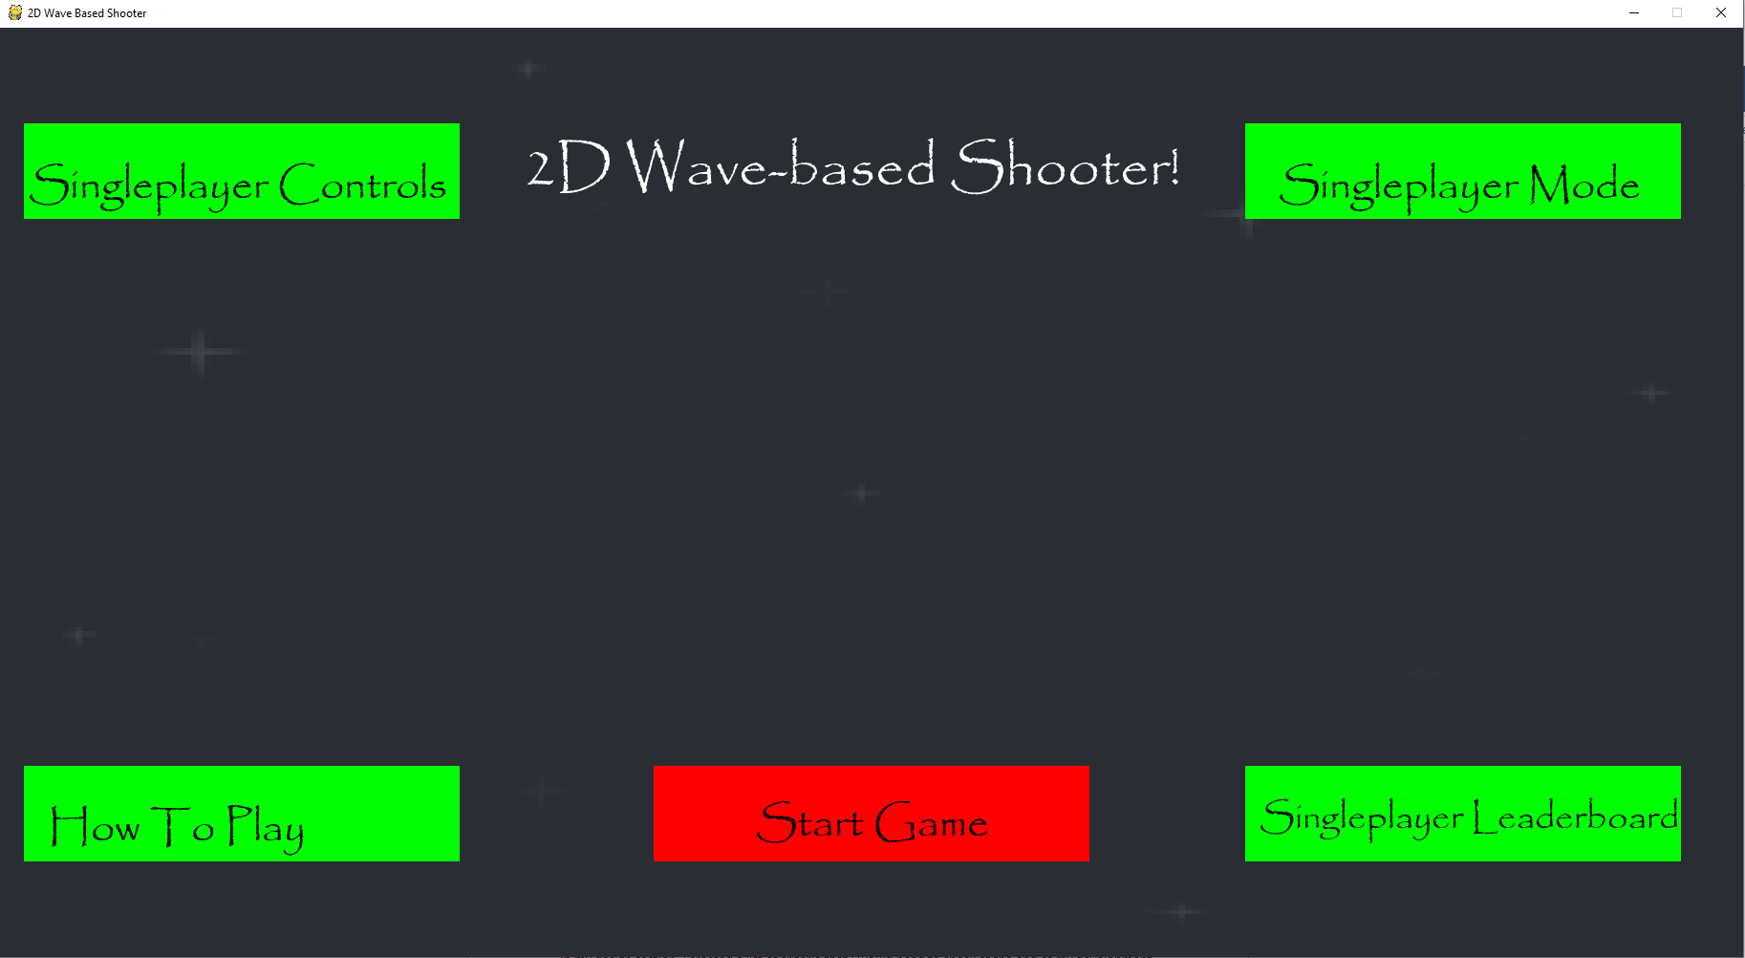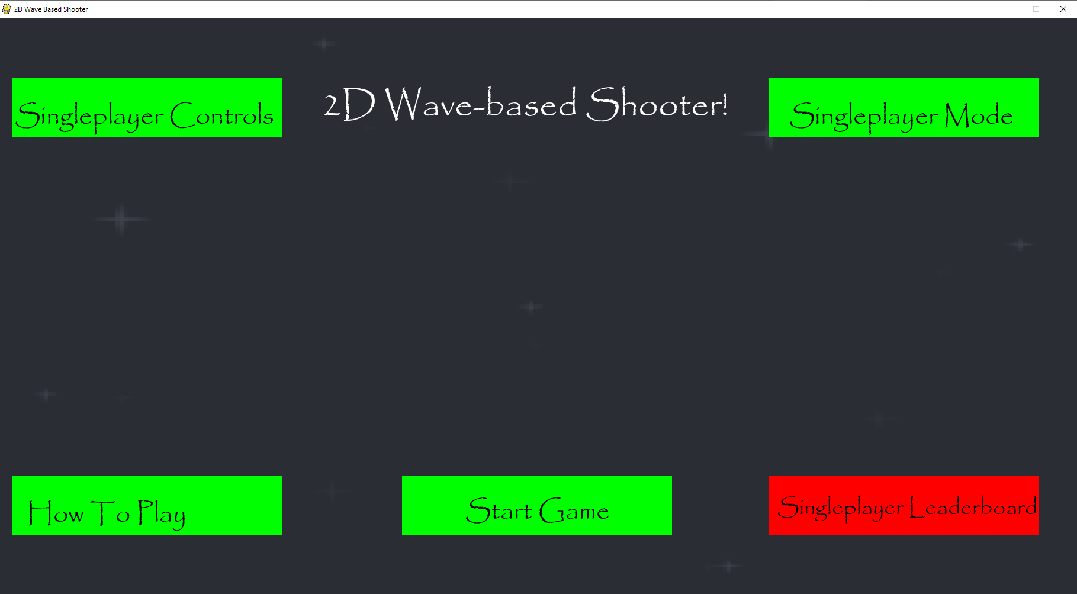

All the sections’ boxes turn red when the mouse goes over them and return to green when the mouse goes off them, so it is easy to tell when you can click on a particular section. In addition, I put my cursor as close to each of the boxes as possible without touching them and they didn’t turn red, so the colour won’t change unless the cursor is hovering over the box.

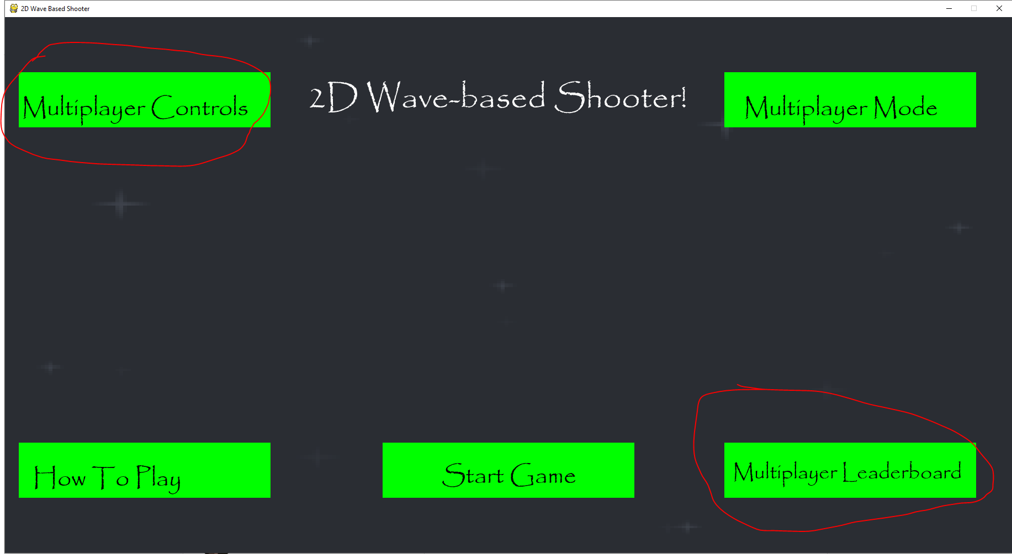Clicking on the singleplayer mode box makes its text change to multiplayer mode so the player knows that two players can now play the game. The text in the controls and leaderboard boxes also change so the player knows there is new information pertaining to multiplayer games only when they click on them.

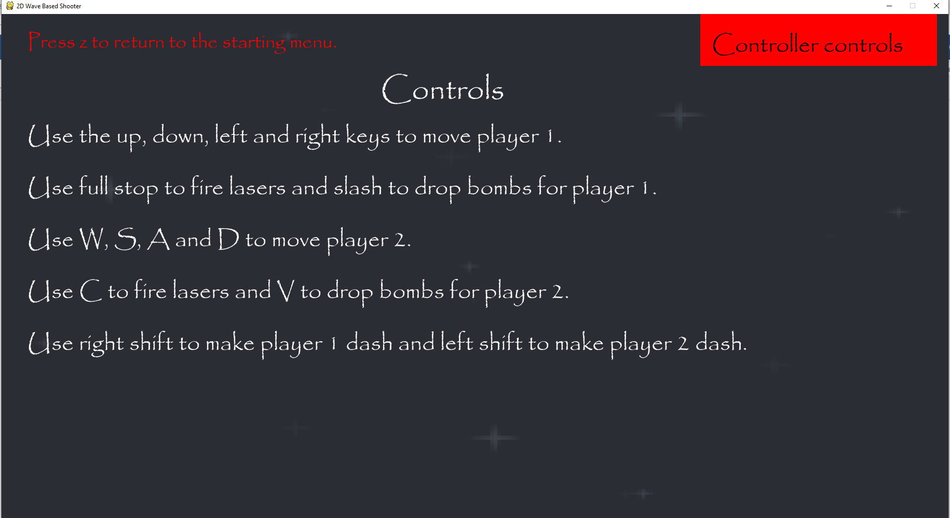In the controls section, in the top left there is some red text telling the player how to return to the main menu and this is in all the sections except the start Game section since that lets you start the game. This makes it easy for people to return to the starting screen of the main menu. In the top right of the screen, there is a box taking the player to the controller controls and it also turns red when the mouse hovers over it.

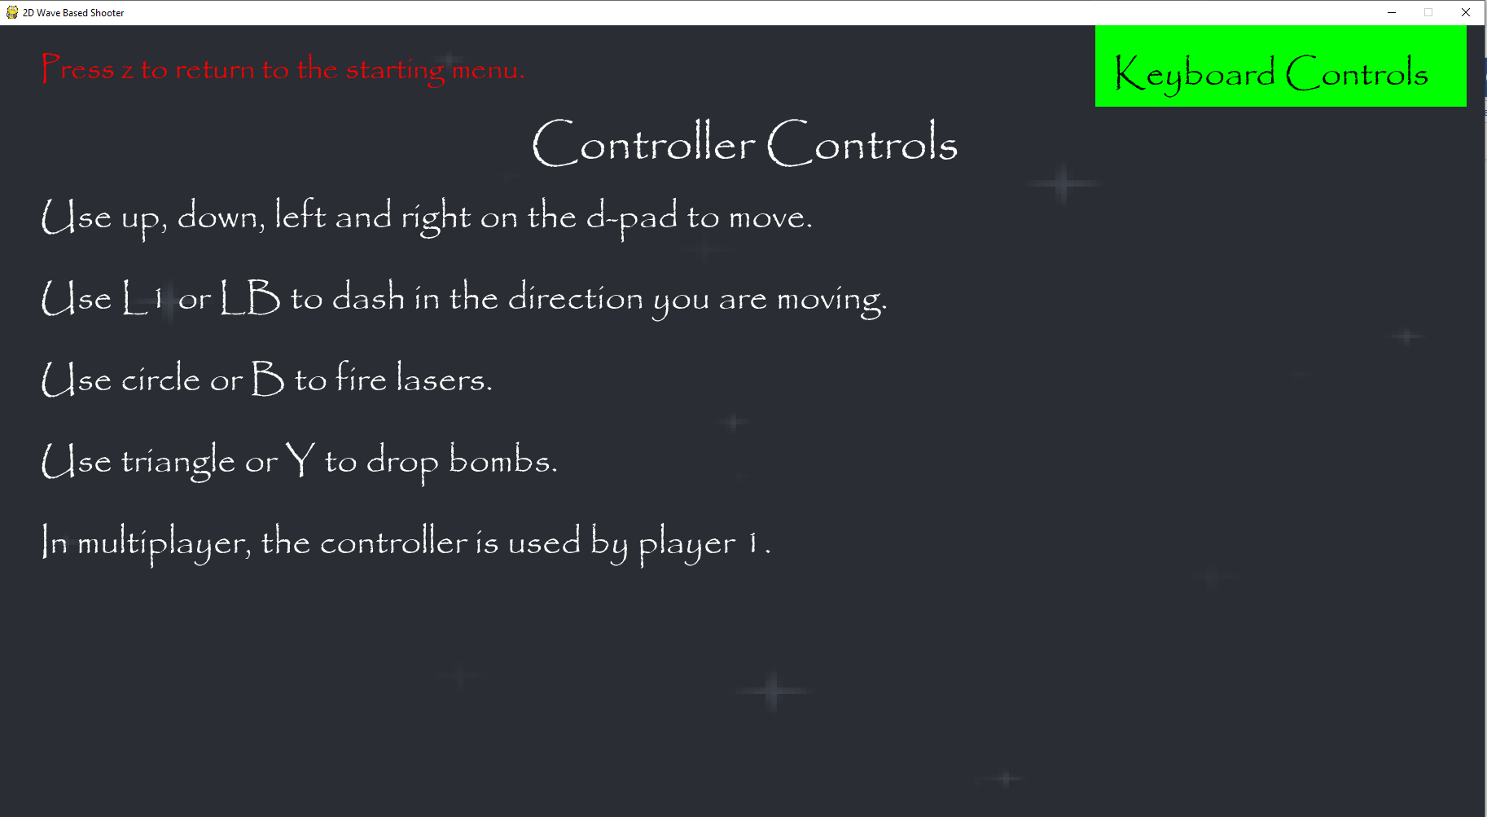Clicking on the controller controls box displays the set of controls needed to play the game using a controller. These instructions are easily understandable for anyone who uses a controller and gives controls for PlayStation and Xbox controllers. The title of the section is also different so that it is obvious that this is a different section, and the game lets the player return to the other controls by pressing keyboard controls box in the top right-hand corner.

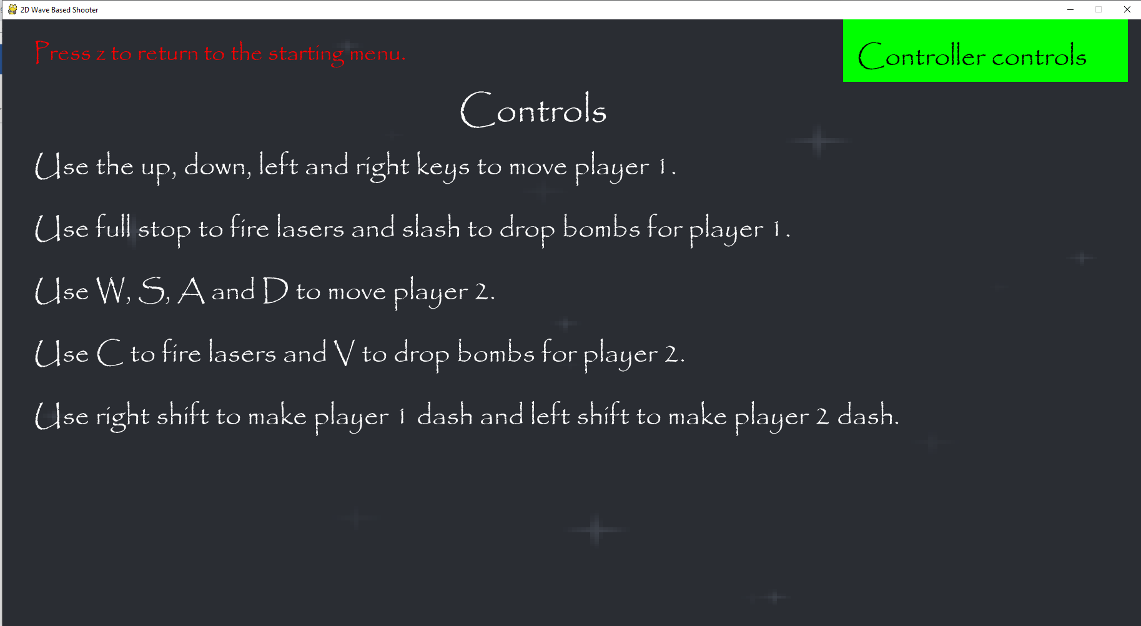Clicking on the keyboard controls will make them return to the keyboard controls section.

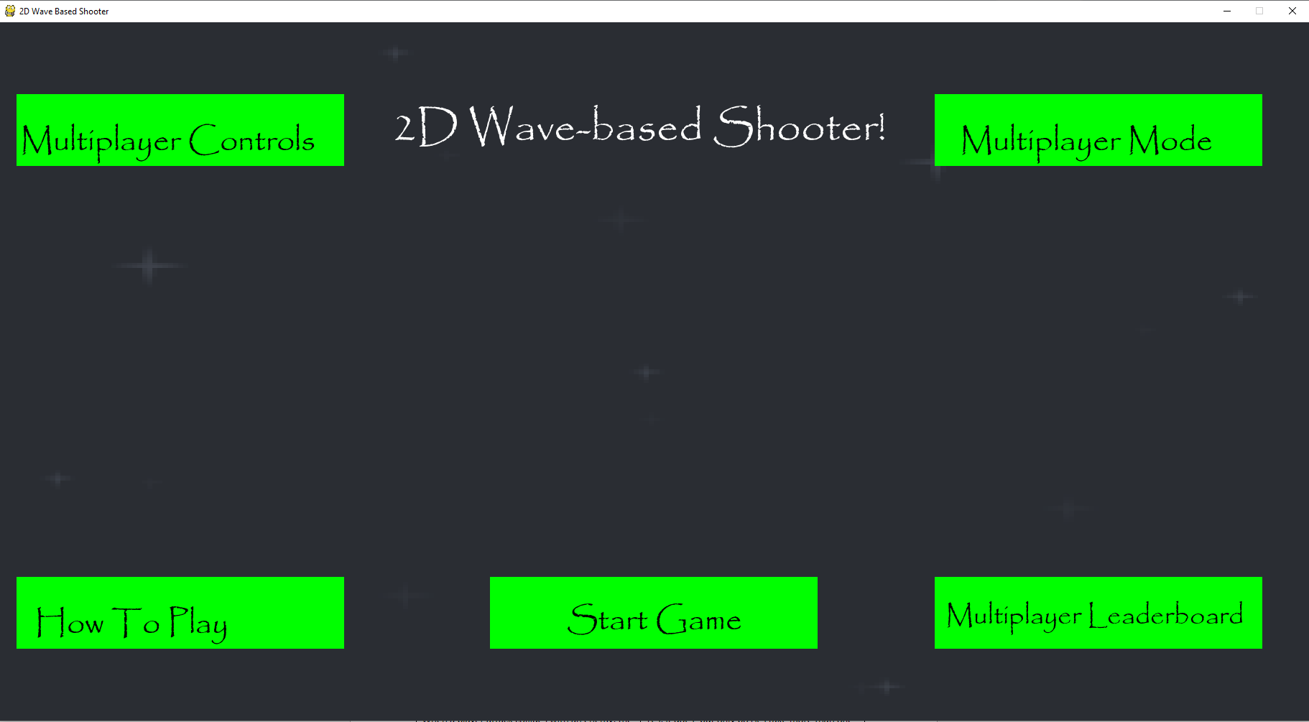I clicked all around each of the boxes and was only able to go to another section when I pressed the mouse button down and the box of that section was red, so the player won’t enter the other section unless their cursor is on that section.

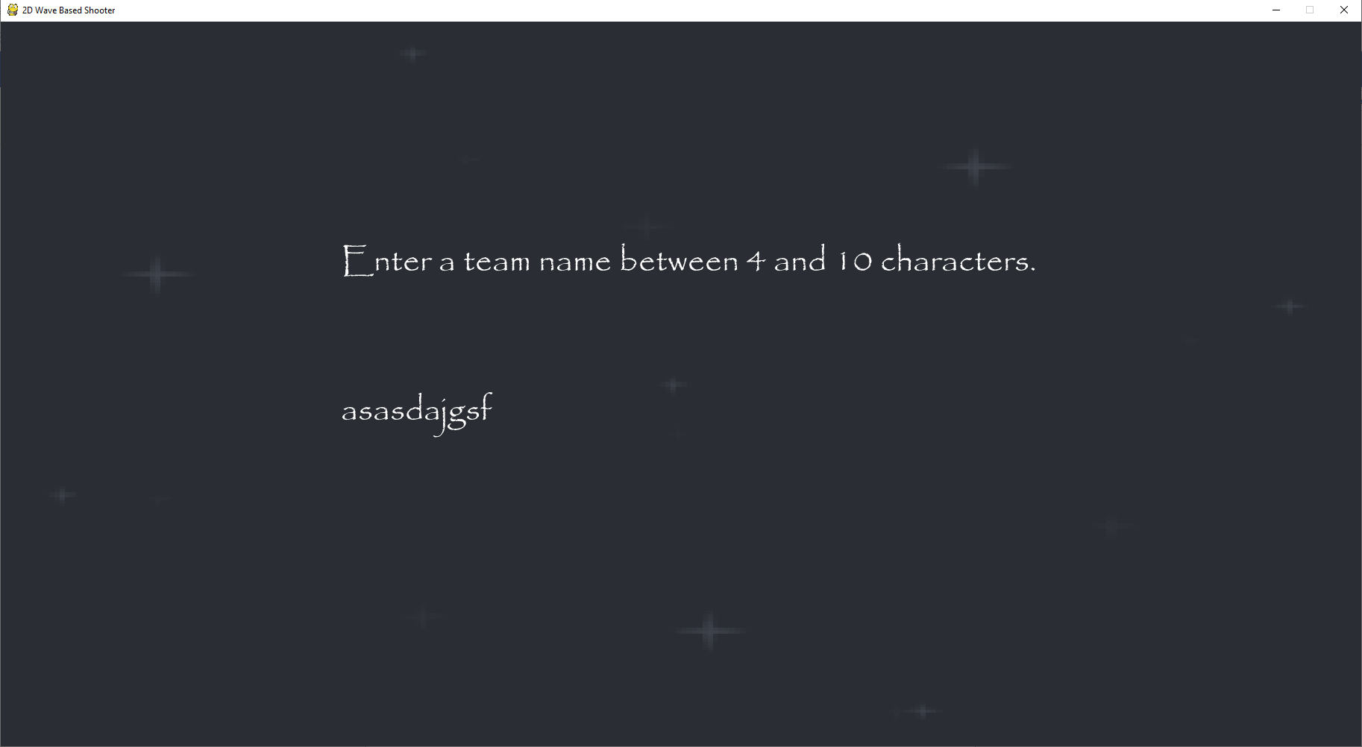When I click start game the game tells me to enter a team name between 4 and 10 characters and the name entered cannot be more than 10 characters as pressing another key after that leads to no characters being entered. However, when the name entered is less than 4 characters the game doesn’t say anything, it just won’t accept it.

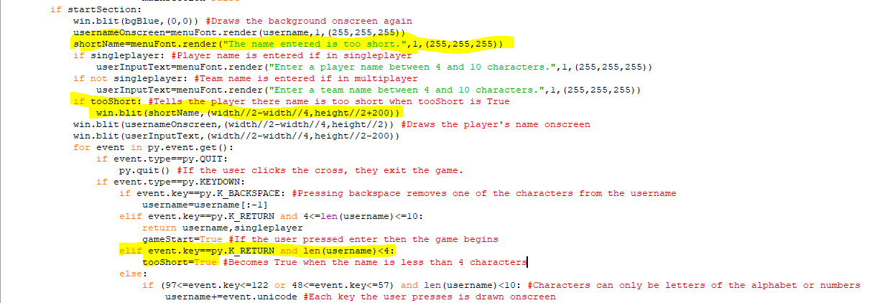I have added in code that makes the variable tooShort become True when the name is less than 4 characters and enter is pressed. When tooShort is True, the game draws text onscreen below where the username is entered to tell the player that their name is too short.

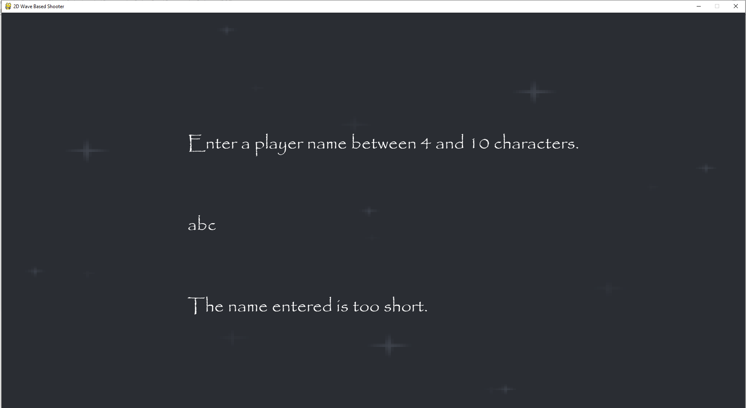This new text is now displayed when the username entered is too short, here at three characters it is saying that the username is too short.

This is a table showing how the username changes when different keys are pressed.

|  |  |  |  |  |
| --- | --- | --- | --- | --- |
| Input | Username | Username length | Valid/Invalid | Output |
| a | a | 1 | Valid | a |
| b | ab | 2 | Valid | ab |
| Enter | ab | 2 | Valid | The name entered is too short. |
| c | abc | 3 | Valid | abc |
| £ | abc | 3 | Invalid | abc |
| Any other non-alphanumerical key | abc | 3 | Invalid | abc |
| d | abcd | 4 | Valid | abcd |
| Enter | abcd | 4 | Valid | No output, but the game begins. |

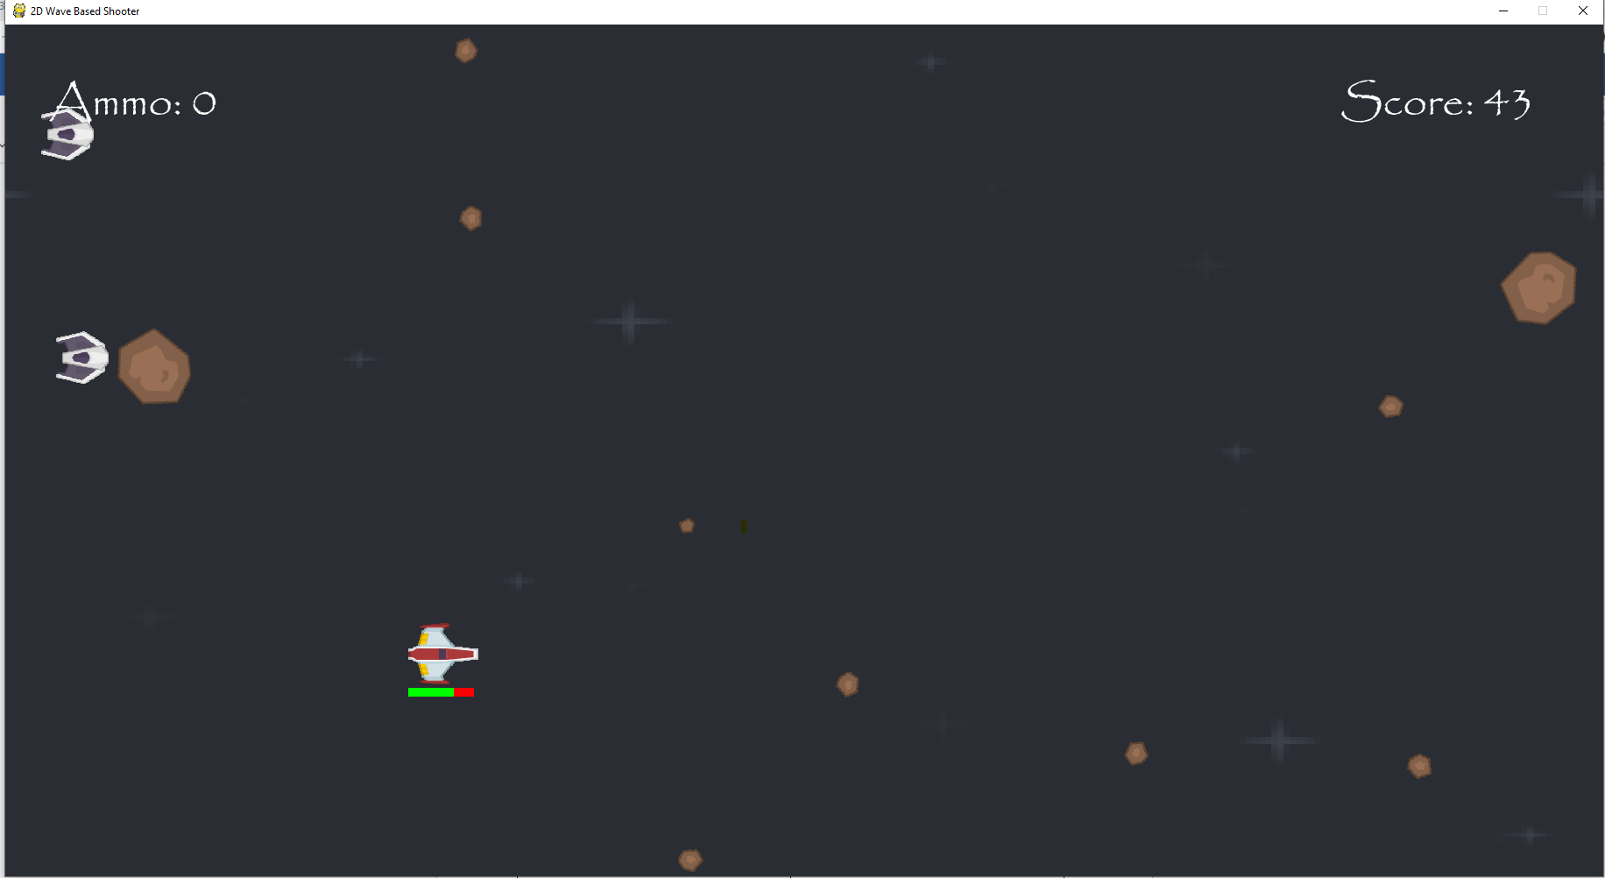In the game itself, when the player loses all their ammo, they can no longer shoot lasers. The ammo and score are also both clearly displayed onscreen with the same font as the main menu, so they are easy to understand.

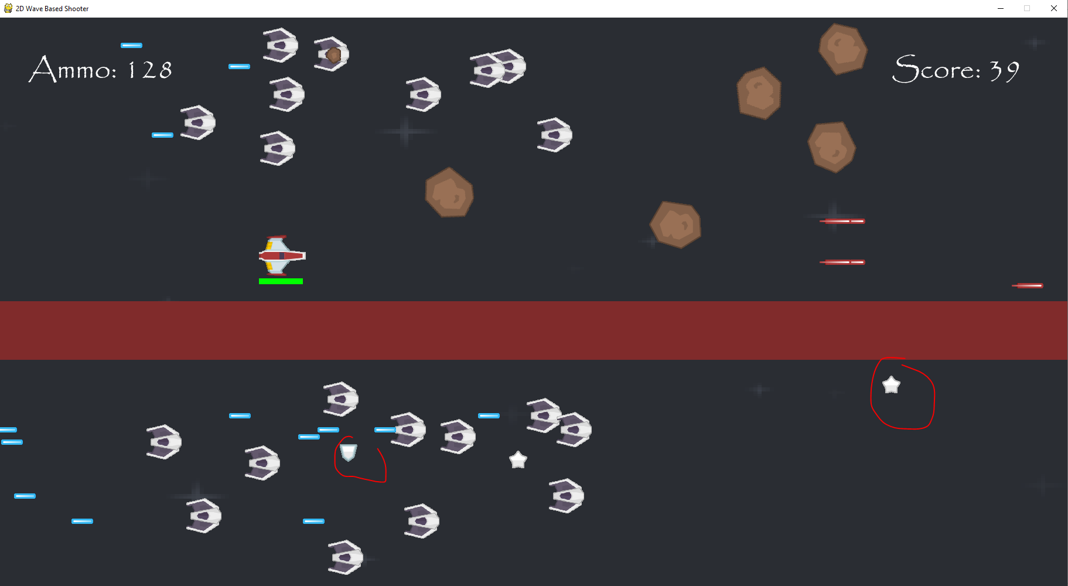Colliding with health and ammo makes more of the player’s health bar green or makes the ammo counter increase respectively. This means that it is easy for the player to tell how much health and ammo they have left in a clear manner.

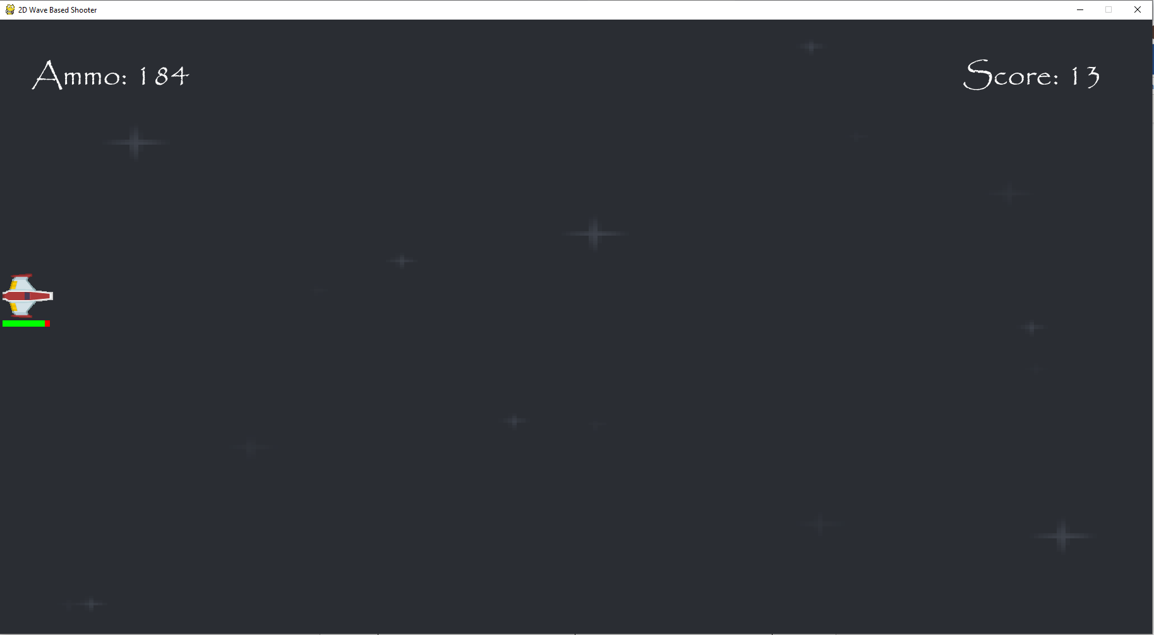I can’t move behind the screen, where the spaceship is right now is the furthest back that the spaceship can go. This prevents the player from accidentally moving their spaceship offscreen and then not knowing where it is anymore since they wouldn’t know the position of that spaceship at that point in time. Also, when I dash leftwards, the player won’t move any further back than this point.

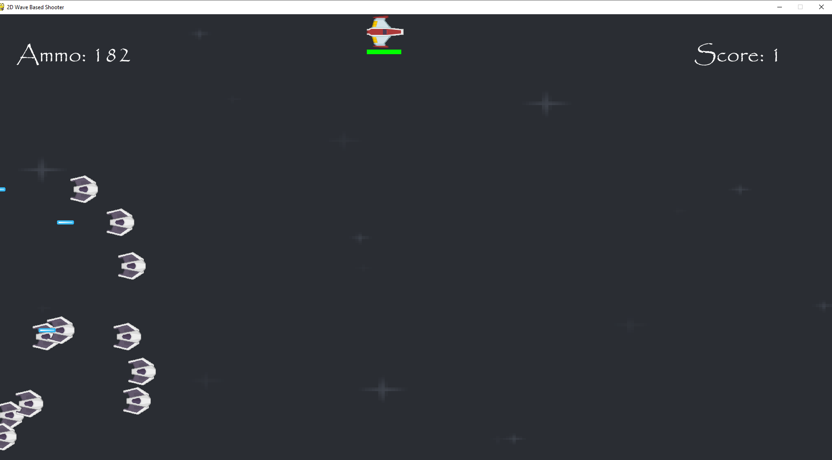I can’t move the player above the screen and when I try and dash upwards this is the furthest up that the spaceship will go.

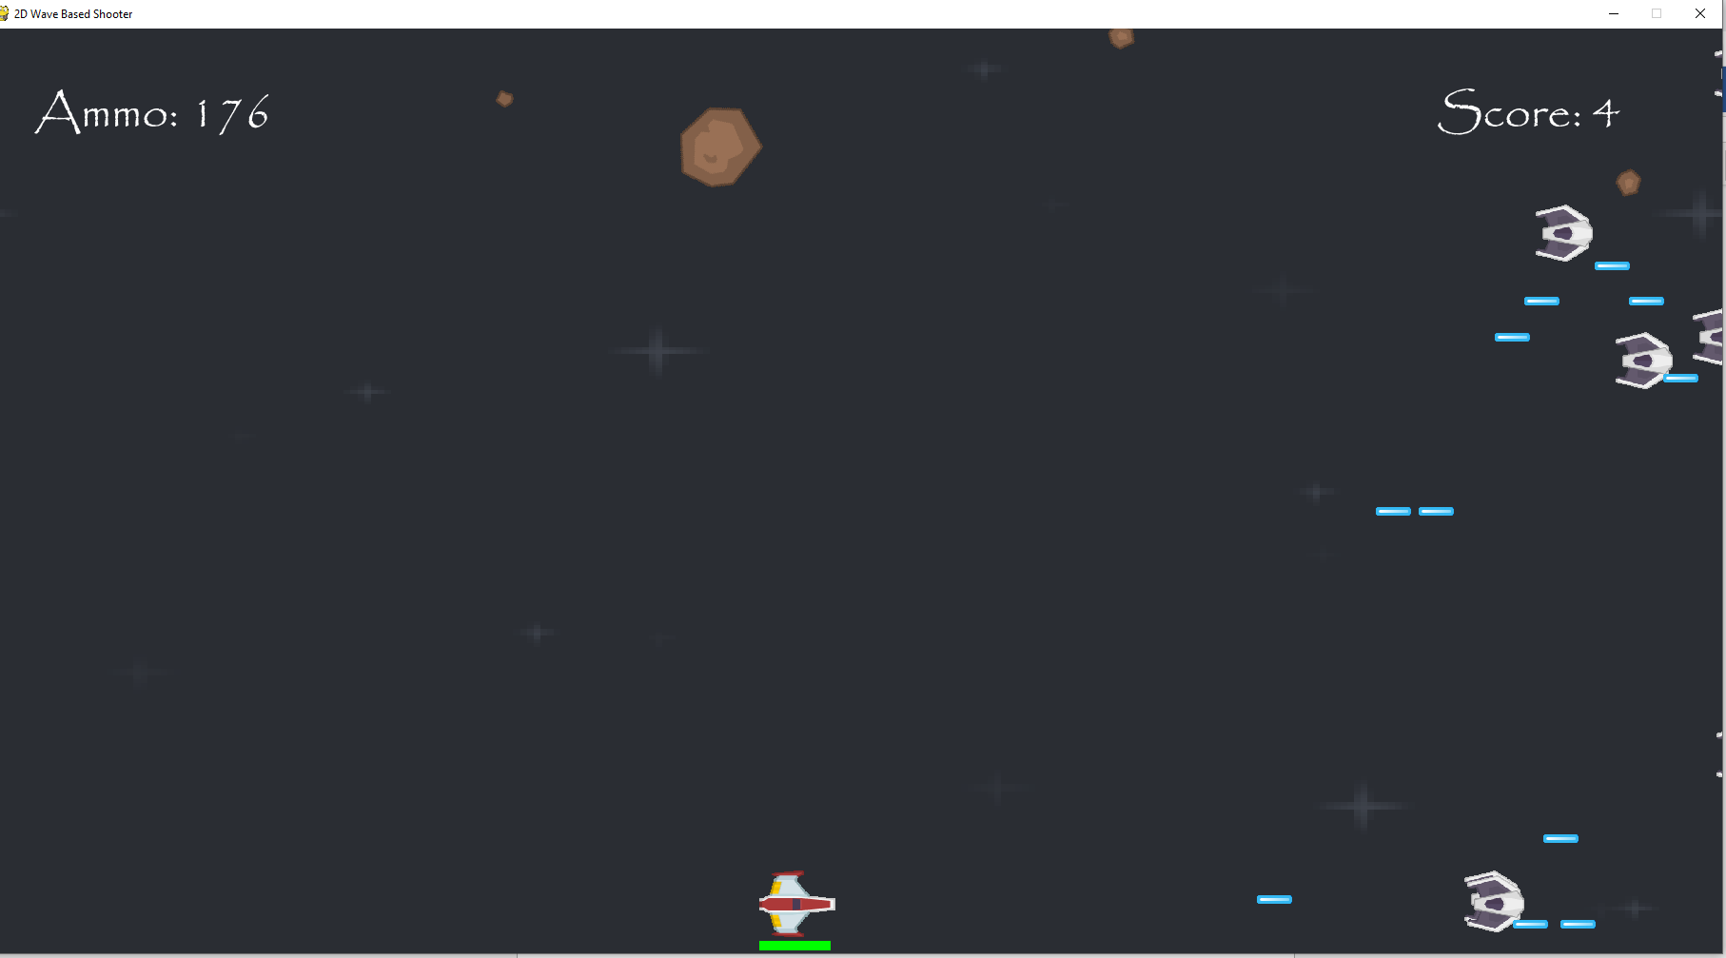I can’t move the spaceship below the screen either. In addition, the health bar is also still above the screen so that the player can always see how much health they have left. I also couldn’t dash below the screen so even when I dashed the health bar was still visible.

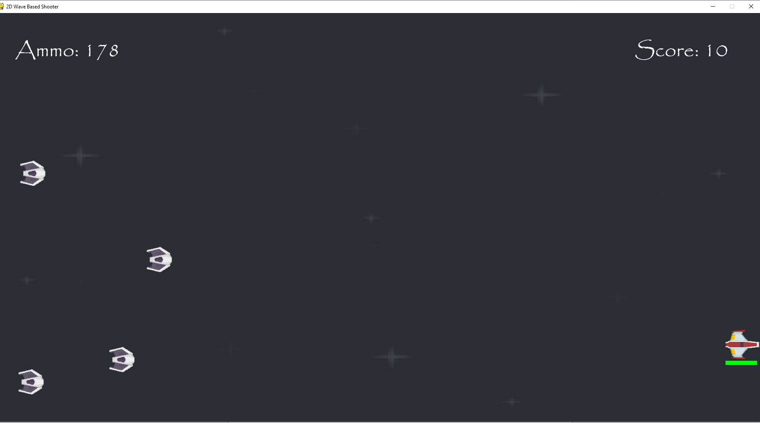I couldn’t move the spaceship in front of the screen by moving it rightwards, so what is onscreen is the furthest forward that it can go. I also can’t dash in front of the screen as dashing in front would just put my spaceship at the x-coordinate it is currently at.

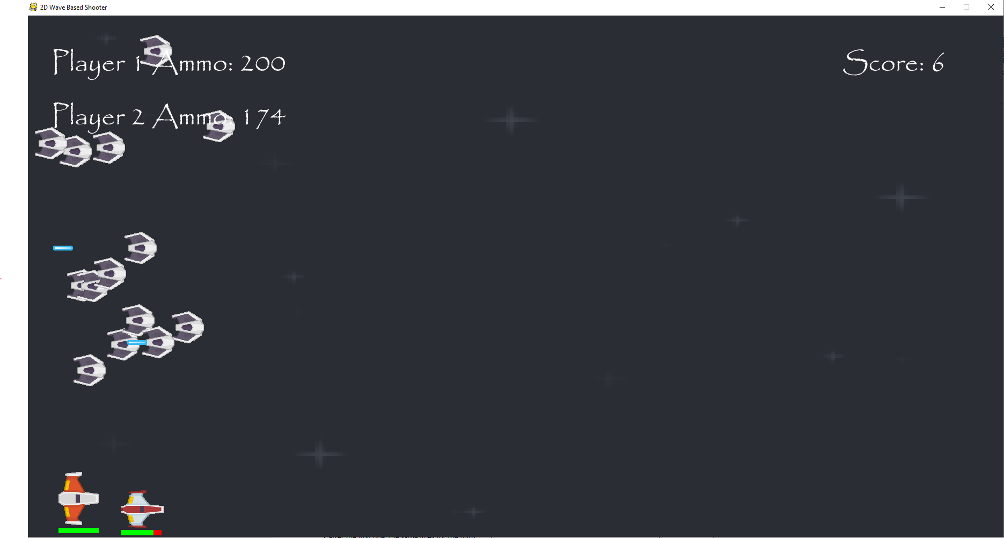In multiplayer mode, neither player can move below the screen or dash below it. The furthest down they can move still leaves their health bars fully visible. If they try and move below the screen then they are just assigned the y-coordinates that they currently have onscreen.

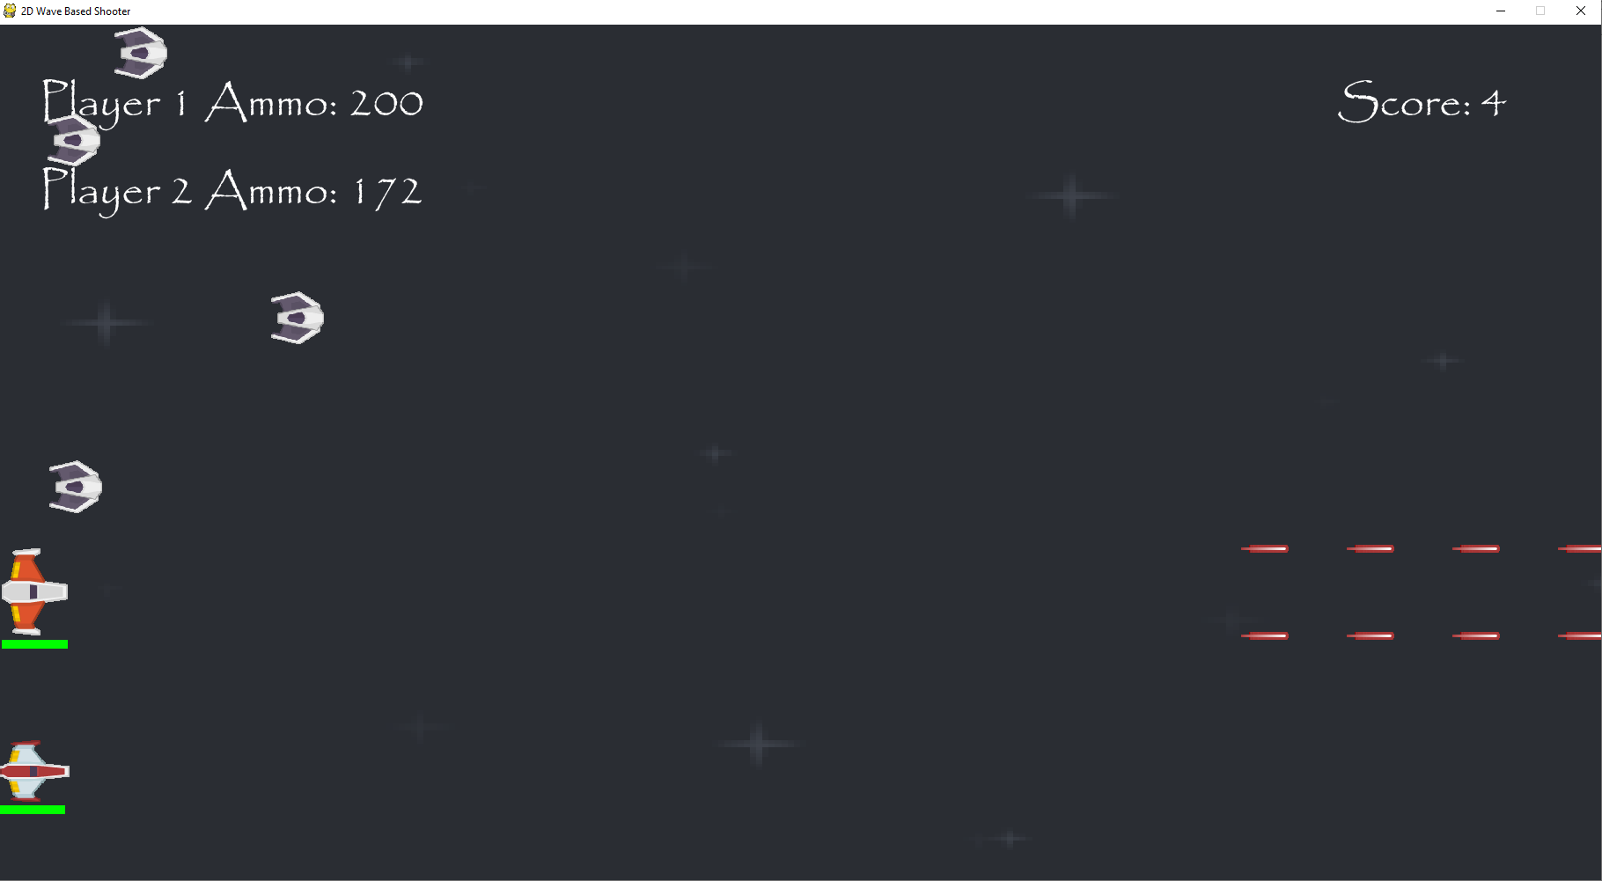Neither player can also move behind the screen nor can they dash behind it. The furthest back that they can move is what’s onscreen now.

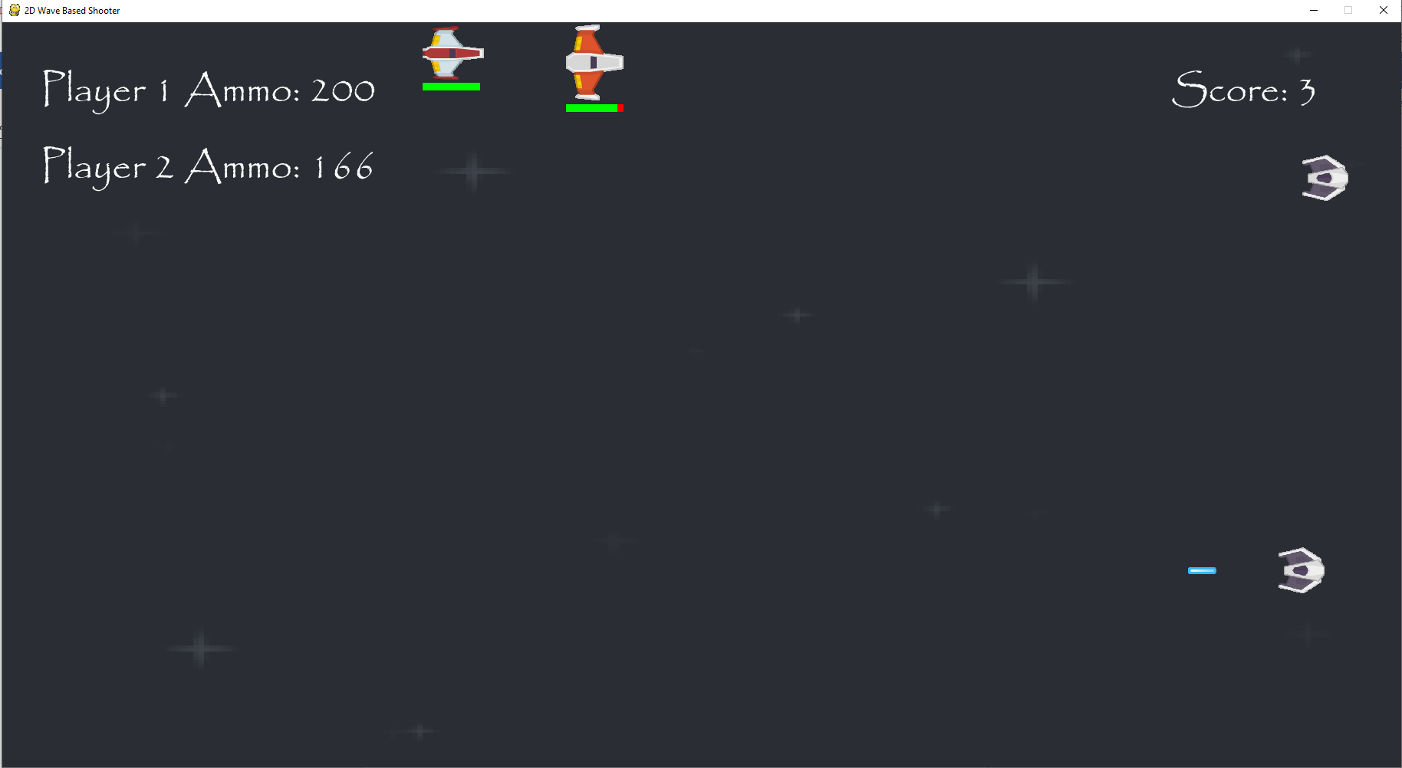Both players can’t move above the screen either, since otherwise they could avoid laser weapons but would also not be visible and could also take unknown damage from meteors. Dashing will also only make the players go as high as they currently are onscreen.

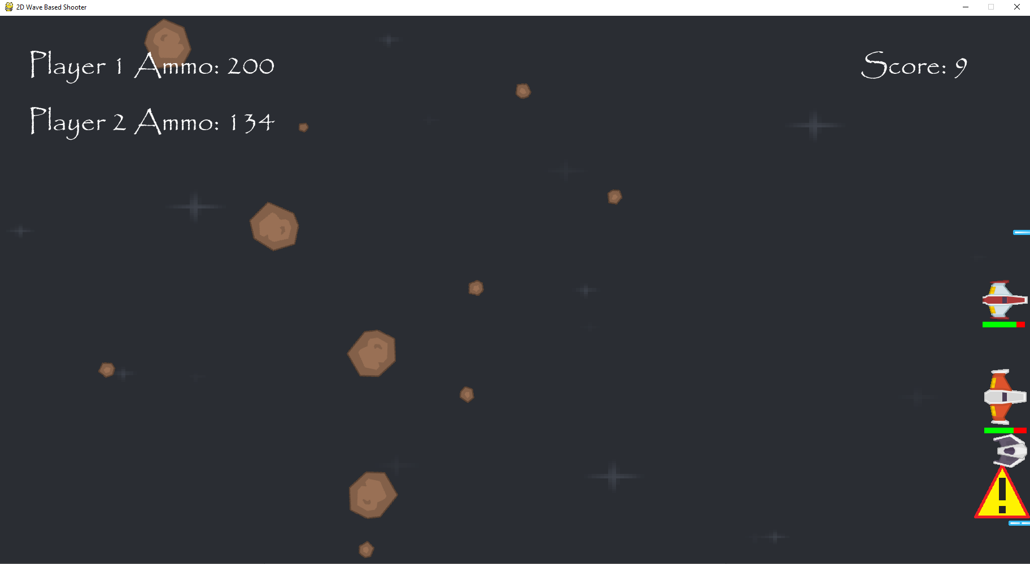Neither player can move in front of the screen with the positions onscreen currently being the furthest they can move leftwards. Dashing also won’t make them move any further forward than they are at this current moment.

Design Checklist

In my design section, I created a list of criteria that I would need to check at the end of my development to see if I had fulfilled all my goals. I will now check to see if that is the case.

This is the list in the design section:

|  |  |
| --- | --- |
| Other actions to test | Does it work? |
| Moving mouse over an icon in the main menu should change the icon’s colour. | Yes, it does |
| Clicking on an icon should take you to the section of the menu the icon points to | Yes, it does |
| When a player attack collides with an enemy, the enemy should lose a fixed amount of health. | Yes, it does- but only bosses take more than one hit to beat. |
| When an enemy loses all its health it should be destroyed. | Yes, it does |
| When a player is hit by an enemy attack or other hazard, they should lose health | Yes, it does |
| Different enemy attacks will do different amounts of damage | Yes, it does |
| When the player loses all their health, gameOver is set to True | Yes, it does |
| The second wave will come in at a fixed time after the first one, the same goes for the third wave, fourth wave etc. | Yes, it does |
| Each wave increases the number of enemies or introduces new enemies. | Yes, it does- except when there would be too many enemies onscreen to handle. |
| The meteors have a small chance of dropping a powerup when destroyed. | Yes, it does |
| When a boss enters the screen, all other enemies stop spawning. | Yes, it does |
| When a boss is destroyed, the game should move onto the next phase with new enemies and hazards. | Yes, it does |
| The leaderboard is updated when the game ends. | Yes, it does |
| When the player dies, their username and score are stored in their own files. | Yes, it does |
| Increase the player score by an amount in line with the difficulty of a given enemy when it is destroyed. | Yes, it does- But extra points are only given for beating bosses, regular enemies all give one point upon destruction. |
| When the player gets a powerup it gives them a certain ability like extra ammo or health. | Yes, it does |
| The controls work for two players. | Yes, it does |

All the criteria in the list have been achieved successfully, so the game does function as I originally intended it to when I made the design section.

Stakeholder Testing

I will let my stakeholders play the game in its entirety and then ask them a series of questions about the game.

These questions are:

1) How easy was it to navigate the menus?

2) How easy was it to understand the controls and how to play the game?

3) How did you find the difficulty of the game over time?

4) How consistent did you find the game’s layout and design?

5) How was the experience changed when in multiplayer?

6) Did you manage to break the game in any way?

7) Would it be easy to remember how to navigate the game’s menu and how to play the game itself even if you hadn’t played the game for a while?

How easy was it to navigate menus?

**Client:** It was very easy; it was laid out and labelled clearly. Also, a button would change color to show that you could click it.

**Stakeholder 1:** The menus were easy to navigate, each having a clearly marked button to reach it. Every menu is accessible from the main screen, making traversal simple and understandable.

**Stakeholder 2:** I found it fairly easy to use, everything had been labeled and organized well. Especially when clicking on it turned a different color to indicate it had been clicked on.

How easy was it to understand the controls and how to play the game?

**Client:** It was quite simple as controls were easy to understand and use. You are told them clearly in the menus for both keyboard and controller.

**Stakeholder 1:** The controls were logical, allowing for easy manipulation of the player character. The concept is straightforward and makes sense, which made the game simple enough to pick up very quickly.

**Stakeholder 2:** The instructions teaching you how to play were straight forward since they followed a universal way of playing on a keyboard so most people would learn quite quickly.

How did you find the difficulty of the game over time?

**Client:** Over time, the game did get easier as you got used to the gameplay, but enemies got harder to keep you on your toes with harder enemies and bosses being introduced.

**Stakeholder 1:** After getting used to the controls, the beginning of the game was fairly easy, but as more enemies were added per wave the difficulty increased rapidly. This meant the challenge of the game was maintained even as I became more experienced.

**Stakeholder 2:** The difficulty of the game over time made it more engaging to the player, since even with more experience you can still have the same amount of curiosity as the first time you played, as it constantly still challenges you.

How consistent did you find the game’s layout and design?

**Client:** I found them consistent since it had a consistent colour scheme and font throughout all of its menus and even in the game itself.

**Stakeholder 1:** The design is fairly consistent throughout, having similar overall theme colours everywhere. The font is also the same wherever it's featured, which further lends to the consistency of the game.

**Stakeholder 2:** The colors showing you and your opposition had been well thought out as they create a contrast making it easy to differentiate between the two.

How was the experience changed when in multiplayer?

**Client:** It made the game more fun. However, you can get crowded with two people over the keyboard, but one person can play on a controller to remove this problem.

**Stakeholder 1:** The multiplayer mode is fun and easy to understand. The controls menu is a little more confusing due to the introduction of player 2 controls and could possibly be reorganised to have separate sections for player 1 and player 2.

**Stakeholder 2:** It made it interesting because if one of you died the game would be over and to stop having to share one keyboard this was resolved by adding a controller; however, the controller's gameplay was a bit harder.

Did you manage to break the game in any way?

**Client:** I had some initial issues when trying to play the game as it would keep crashing. But when that was fixed, I had no issues.

**Stakeholder 1:** Overall, the game runs smoothly, and I couldn't find any bugs or errors. The movement and collisions work consistently, and I didn't see any visual glitches.

**Stakeholder 2:** The game ran smoothly and there were no real way of breaking the game that I could find in the game itself.

Would it be easy to remember how to navigate the game’s menu and how to play the game itself even if you hadn’t played the game for a while?

**Client:** Yes, because everything is clearly labeled so you know where everything is. The consistency of the game’s layout also makes the game easy to understand.

**Stakeholder 1:** The game uses logical controls, many of which are common to games in the same genre. This makes them easy to remember. The straightforward premise of the game means that even coming back to it after a long while, I believe it would be easy to pick up again.

**Stakeholder 2:** Yeah, I had played this game in its earlier production and almost instantly I managed to play smoothly again.

Overall, the stakeholders were able to play the game fine and found it easy to navigate through the different menus. They all said that the game’s layout and design remained consistent throughout and that use of the use colours and fonts meant that clicking on different sections and choosing different options was simple to do. In addition, all of them said that it would be easy for them to play and navigate the game even if they hadn’t played the game in a long amount of time. Moreover, they all said that the controls were simple to understand as they were easily found and were quite universally used in videogames. The game was also unable to be broken by them in any way which means that the code itself is robust and well-written.

The only complaint was that the controls for two players was a little hard to understand but this could be fixed by putting the controls for player 1 and player 2 on separate pages in the main menu, and this could be implemented in the game if I were to continue it.